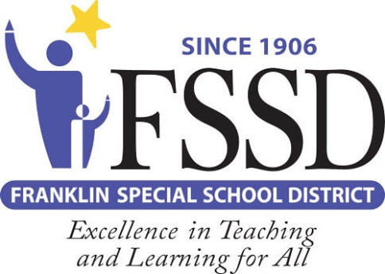
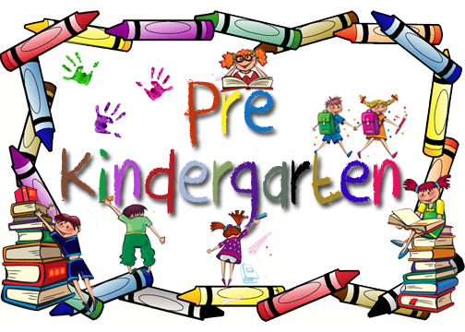

Voluntary Pre-K is a state funded program for families who meet income qualifying guidelines
Families who have children who were born on or between August 16, 2016 and August 15, 2017 are eligible to apply
Classes meet in all 5 FSSD elementary schools
Mon.-Fri. 8:00 AM-2:00 PM

Parents provide transportation.
PLEASE COMPLETE A VOLUNTARY PRE K APPLICATION ONLINE AT WWW.FSSD.ORG
https://tinyurl.com/FSSDVPK
https://tinyurl.com/FSSDVPKSPA

2021-2022

Voluntary Pre-K Program

